Дизайн и верстка страницы сайта конференции

Задание:
Разработать дизайн и сверстать главную страницу для сайта международной конференции, используя вводные данные:
1. набор изображений и текстов;
2. Mockup:
- главная страница сайта в исходном виде и с развернутым меню
- страница одной из тематик конференции: Business Intelligent.

Указания к реализации
Иконка в правом верхнем углу страницы должна разворачивать меню при наведении. Содержание меню показано ниже.
Меню справа должно содержать ссылки на другие разделы. Ссылка на «Business Intelligent” должна открывать соответствующую страницу, остальные ссылки - на пустой адрес или заглушку.
Цвета или изображения фонов, а также шрифты подберите самостоятельно.

Mockup
Главная страница
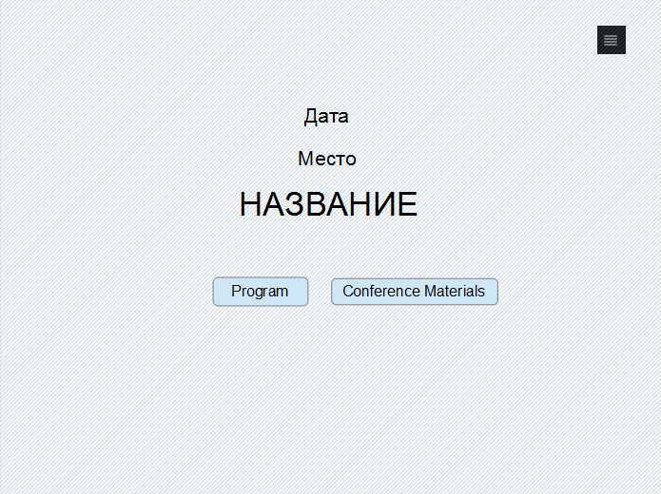

Главная страница + меню
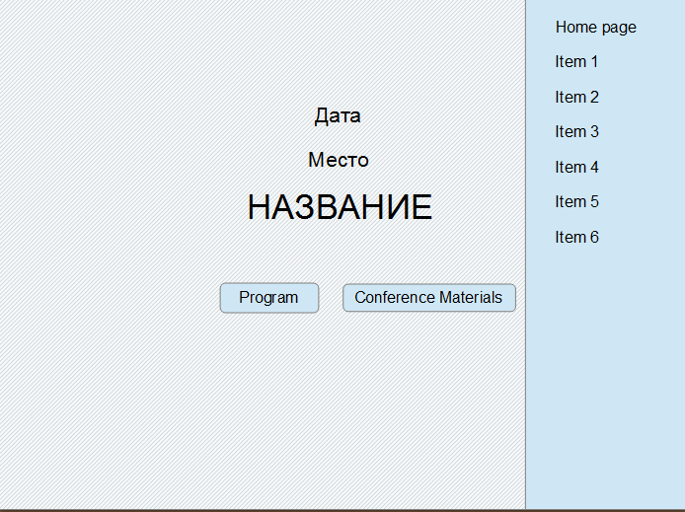
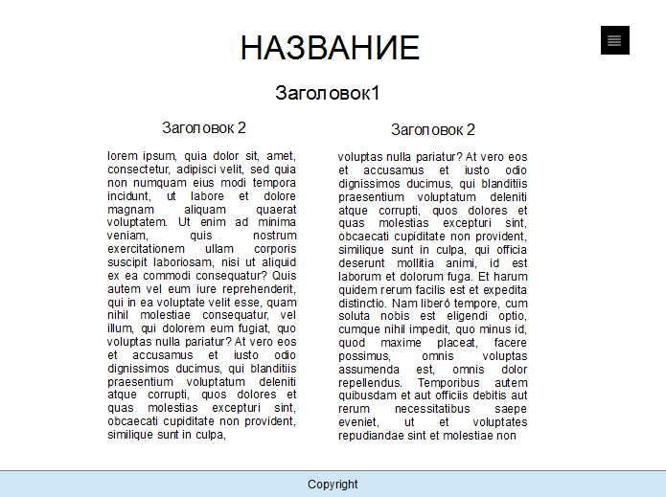
Страница «Business Intelligence»
Содержание главной страницы
10-12 November 2016
Saint-Petersburg
AINL FRUCT: Artificial Intelligence and Natural Language Conference

Меню:
Home page
Call for Papers
Registration
Program
Runs
Business Intelligence
Accomodation

Содержание страницы «Business Intelligence»

Business Intelligence
Russian Presidential Academy of National Economy and Public Administration (RPANEPA) is organizing the Business Intelligence section in conjunction with the AINL-FRUCT-2016 Conference.

About

The term Business Intelligence (BI) may be interpreted as a combination Business Applications + Artificial Intelligence. The key element in the formula is 'Intelligence', which supposes processing unstructured noisy data. BI takes its roots in decision support systems and expert systems for business applications, which appeared at 1970s-1980s.
Howard Dresner, the analyst at Gartner, defined BI as a general term describing "concepts and methods for improving process of decision-making using systems on the basis of business data" (1989). BI and business analytics (BA) sometimes are used as synonims although there is a difference between them. BI focuses on the search of useful information using heuristic methods while BA focuses on analysis of current situation on the basis of statistical methods. BA is considered as a part of BI.

Date
The date of session is November 11 or 12, the exact day will be announced later.

Program

Mathematical Modeling of Information Processes in a Society

Olga Proncheva,
Ph.D. student of the Keldysh Institute of Applied Mathematics RAS, assistant of the Moscow Institute of Physics and Techlnology

Abstract.
The current stage of social development is characterized by a sharply increasing role of information environment. Mass-media has a specialrole in information dissemination, because this process begins with propaganda and only then moves to networks. This is why we focus on the role of the media in information processes.The lecture is devotedto mathematical models of information dissemination. Within the limits of their applicability they allow to examine qualitatively the natureof information processes. Some computational and analytical results are presented. It is shown that a number of significantly different scenarios can occur.

Processing queries to search engine of Yandex: possibilities of analysis and forecast

Anna Boldyreva,
M.Sc. student of the M.Sc. program RANEPA-MIPT

Abstract.
Search queries to Internet are a real reflection of events and
processes that happen in the informative society. Moreover, the recent research shows that search queries can be an effective tool for the analysis and forecast of these events and processes. In the lecture, we present our experience in creating databases of descriptors (queries and their combinations) to be used in real problems. Examples
related to the analysis and forecast of regional economy and regional police work illustrate an application of the mentioned descriptors.

Invited speakers
Vadim Strijov
Dr.Sc., senior researcher of Computer Center of the Russian Academy of Sciences
"Feature generation for multiscale time series forecasting"
(tutorial by skype, 4 hours)

Participation in the section
Participation without publication. For this one needs to inform the Program Committee about poster presentation.
Deadline: September 30, 2016

Participation with publication. For this one needs to submit short or long paper in according with AINL-FRUCT requirements.
Deadline: September 15, 2016

